31.25: a) 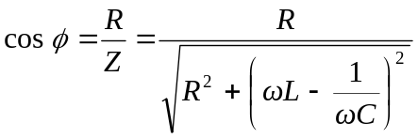
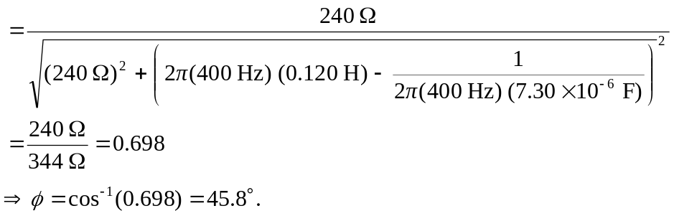

b) 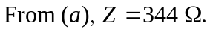
c)
d)
e) 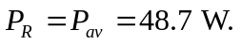
f) Zero.
g) Zero.
For pure capacitors and inductors there is no average energy flow.

